APPEL DE PROCEDURE STOCKEE EN C#(WINDOWSFORM+WEBFORM)

1-procedure PC2

create procedure pc2 @a int

as

begin

select * from client where code=@a

end

exec pc2 2

**WEBFORM a realise:**

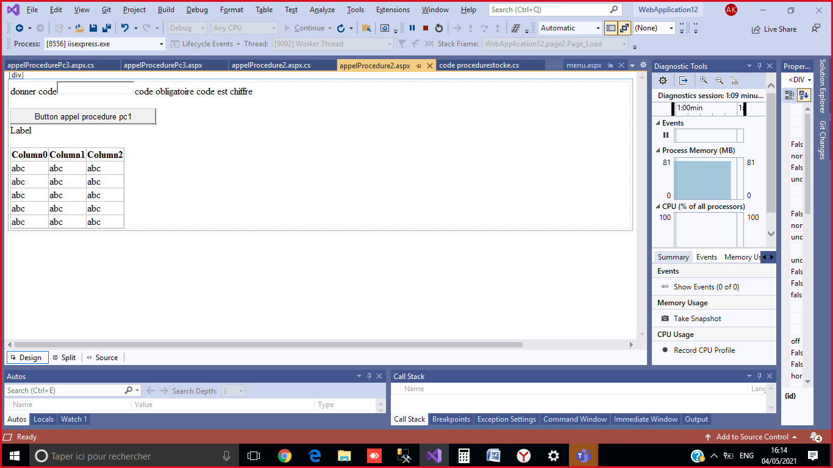

**Code button:**

protected void Button1_Click(object sender, EventArgs e)

{

String chaine = @" DESKTOP-6PP7PSR\MSSQLSERVER01;Initial Catalog=clients;Integrated Security=True";

SqlConnection con = new SqlConnection(chaine);

con.Open();

SqlCommand cmd = new SqlCommand("pc2", con);

cmd.CommandType = CommandType.StoredProcedure;

SqlParameter codeparameter = new SqlParameter("@a", SqlDbType.Int);

codeparameter.Direction = ParameterDirection.Input;

codeparameter.Value = Convert.ToInt32(TextBox1.Text);

cmd.Parameters.Add(codeparameter);

SqlDataReader dr = cmd.ExecuteReader();

DataTable t = new DataTable();

t.Load(dr);

GridView1.DataSource = t;

GridView1.DataBind();

con.Close();

}

**2-procedure PC3**

Create Procedure pc3(

@nomclient varchar(20),

@n Integer OUTPUT)

AS

begin

select * from client

where nom=@nomclient

set @n = @@Rowcount

--nombre de ligne de la derniere requete

return convert(int ,getdate())

end

declare @x int

declare @r int

exec @r=pc3 'Moaad',@x output

print @x

print @r

**Interface graphique du webform :**

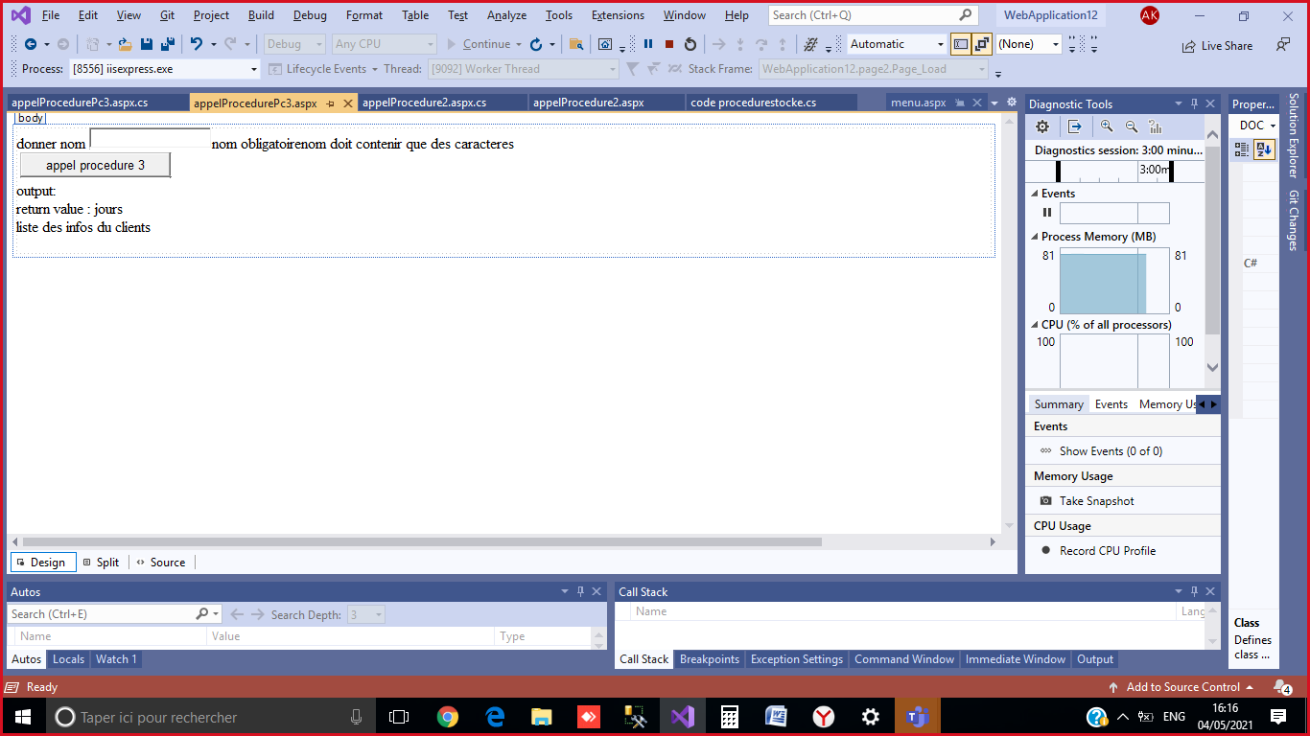

**Code button :**

protected void Button1_Click(object sender, EventArgs e)

{

String chaine = @"Data Source=.\SQLEXPRESS;Initial Catalog=clients;Integrated Security=True";

SqlConnection con = new SqlConnection(chaine);

con.Open();

SqlCommand cmd = new SqlCommand("pc3", con);

cmd.CommandType = CommandType.StoredProcedure;

//input

SqlParameter p1 = new SqlParameter("@nomclient", SqlDbType.VarChar, 20);

p1.Value = TextBox1.Text;

p1.Direction = ParameterDirection.Input;

//output

SqlParameter p2 = new SqlParameter("@n", SqlDbType.Int);

p2.Direction = ParameterDirection.Output;

//retvalue

SqlParameter valeurRetparametre= new SqlParameter("RetVal", SqlDbType.Int);

valeurRetparametre.Direction = ParameterDirection.ReturnValue;

cmd.Parameters.Add(p1);

cmd.Parameters.Add(p2);

cmd.Parameters.Add(valeurRetparametre);

SqlDataReader dr=cmd.ExecuteReader();

while (dr.Read() == true)

{//select

string code = dr.GetValue(0).ToString();

string nom = dr.GetValue(1).ToString();

string password = dr.GetValue(2).ToString();

Label4.Text += " code :" + code + " | nom=" + nom + " | password: " + password;

}

dr.Close();

cmd.ExecuteNonQuery();

Label2.Text += " valeur =" + p2.Value.ToString();

Label3.Text += "retour=" + valeurRetparametre.Value.ToString() + " jours depuis 1900";

con.Close();

}